TOUGH PRIMARY SCHOOL
Newsletter 3
20th December 2019
Dear Parents

What a fantastic term we have had! Read on for more information about what we have been up to.

Visit to Stewart Milne Development
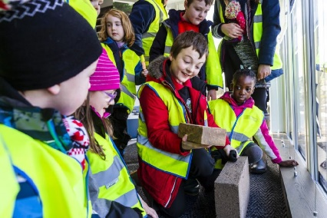
Primary 1-4 had a great time during their visit to the Stuart Milne sales office and show home. We learned all about how a house was built and designed and looked at the different materials used. We also learned about keeping safe on building sites and the different jobs that people had there. This was a great opportunity to build on the learning we have carried out this session about houses and homes. It also contributes to our work to Develop our Young Workforce and helps to develop community links.

Forest Schools Outdoor Learning
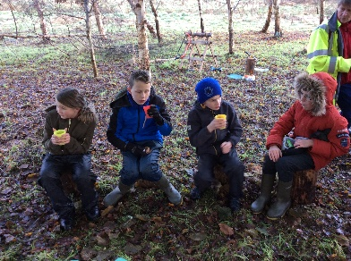
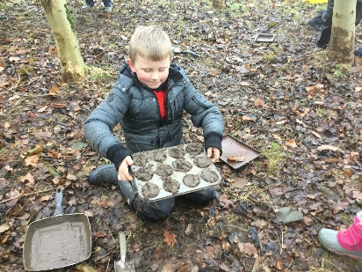
We have been lucky enough to have been allowed to use the land opposite the school for Forest Schools outdoor learning opportunities. Lindsey Duncan, a trained level 3 forest schools practitioner organised these sessions in which the pupils have a wide range of learning activities to choose freely from. These included den building, using hammocks, a mud kitchen, clay activities and sawing their own wood medals to decorate. We have received very positive feedback from the pupils and look forward to more of these sessions in the new year.

Bridges
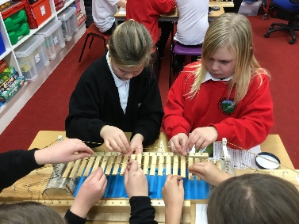
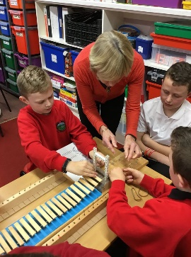
P5-7 had a visit from the Harpers as part of their ‘bridges’ topic. Douglas Harper's great grandfather and grandfather designed the Harper Suspension Bridge which is a pedestrian bridge that can be found all around the world. The furthest away example Douglas has been to see so far is in Nepal! P5-7 had great fun building their own Harper bridge models and learning all about them.

Open Morning
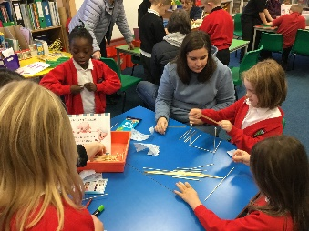
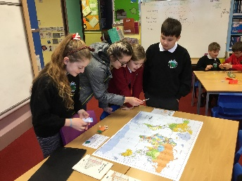
We were delighted that so many parents were able to attend our open morning as we recognise how difficult it can be to attend events during the day. We were able to share the learning taking place with Modern Foreign Languages in our schools and work together on topic related learning activities. It also gave us the opportunity to respond to parent feedback regarding assessment and to share our Curriculum Rationale.

General Election Closure Day
As we were unable to use the school building we carried out development work elsewhere. This included working on our Learning, Teaching and Assessment policy, promoting high teaching standards as well as planning for a Developing the Young Workforce fortnight next term and collating useful activities and websites for Glow to provide learning opportunities in case of snow related closure days.

Christmas Show
I’m sure you will agree that our Christmas show, ‘Lights, Camel, Action!’ was a huge success! We are very proud of how well the pupils performed and seeing how confidently they played their parts. Thank you for coming along and supporting us, we hope you enjoyed it!
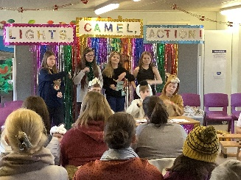
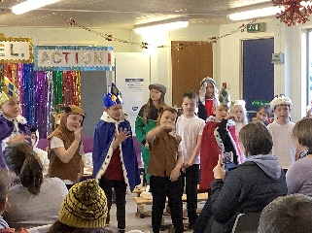
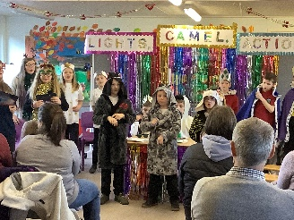
Christmas Raffle
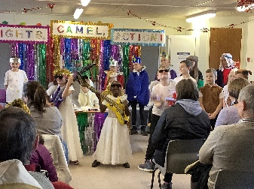
Our Christmas Raffle raised a staggering £1326.16 this year! This is a fantastic amount, especially for a small school and we appreciate the hard work put in by all to sell tickets. This money can be used towards exciting school trips and learning experiences in the future. Thank you to our School Interest Committee for organising this.

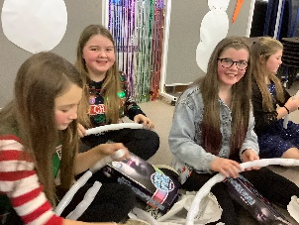
Christmas Party
We had a great time at our Christmas party and it was great to see everyone enjoying themselves. The children were delighted with their gifts from Santa. Thank you to his special elves for helping him organise this!

Christmas Jumper day
It was lovely to see the pupils in their Christmas jumpers and we have managed to raise £31.00 for Save the Children. We will learn more about the projects this money will go towards in the new year.

Parent Questionnaire
Thank you again very much for your responses to our parent questionnaire. I shared these with our parent council along with next steps related to the answers. This included sharing assessment information in our open morning and working on whole school activities to address bullying concerns. I was pleased with the positive feedback received and look forward to building on this good work in the future.

Next Term
We have lots of exciting plans in place for next term. Primary 5-7 will be learning about ‘The Romans’ and Primary 1-4 will be carrying out a history project based around ‘’Granny’s Attic’. As mentioned, we are planning a variety of events to ‘Develop our Young Workforce’ and we will also have Health and Wellbeing visits from ALEC. Our digital leaders will also begin our journey towards becoming ‘E-safety Ambassadors’ as a next step from our Digital Schools Award. Some of our P6/7 pupils will also attend the Ski Trip.

Staffing
Mrs. Laura McAllister will return in a part time capacity in a 0.5 job-share position after the holidays. I am delighted to share with you that I have been successful in being appointed to the other half of this post after going through the interview process over the past month. This provides us with consistency in bringing forward the good work over the last year into the future. I will also retain my post as head teacher relief so I will be in the school full time.

Thank you very much for your support over the last year. I look forward to continuing to work together in the future. As always, if you have any concerns or queries please do not hesitate to contact me.

Kind Regards

Kerry Porter
Joint Head Teacher

Information for School Closures/Adverse Weather

Telephone Information Line: 0370 054 4999
Tough School Pin Number: 02 2720
ABERDEENSHIRE WEBSITE HYPERLINK "http://www.aberdeenshire.gov.uk/closures"
http://www.aberdeenshire.gov.uk/closures
TWITTER HYPERLINK "http://twitter..com/aberdeenshire"
http://twitter..com/aberdeenshire
(The web page is re-set at 4pm every day to be clear for next day’s information)
Northsound 1 FM 96.9 Tel. 01224 337000
Northsound 2 MW 1035kHz
BBC Radio Scotland FM 92.4-94.7 MW 810kHz
Moray Firth Radio FM 97.4 MW 1107kHz
Waves Radio FM 101.2 Tel. 01779 491012
Original FM 106 Tel. 01224 293800

Dates for the Diary 2019/2020

Friday 20th December, 2019 Church Service & Last day of term
Monday 6th January, 2020 Term Starts
13th-17th January, 2020 P1 Registration Week
Thursday 16th January, 2020 P1 Enrolment Day 11am – 12.30pm
Tuesday 21st January 2020 Parent Council Meeting – 7.15pm in Tough School
Monday 27th January, 2020 Admission Packs for August, 2020 P1 to be returned
Thursday 13th February, 2020 School Closed – Holiday
Friday 14th February, 2020 School Closed - Holiday
Monday 17th February, 2020 School Closed - Holiday
Tuesday 18th February, 2020 In Service Day
Wednesday 19th February, 2020 In Service Day
Tuesday 3rd – Friday 6th March,2020 P6/P7 Ski Trip with Dunecht School
9th – 20th March, 2020 Developing Young Workforce Fortnight-details to follow
Thursday 19th March, 2020 P1 and P7 Dental Inspection
Friday 3rd April, 2020 Church Service & Last Day of Term
Monday 20th April, 2020 Term Starts
Thursday 30th April, 2020 Hamewith Concert
Saturday 2nd May, 2020 Midmar Football/Netball Tournaments
Tuesday 5th May, 2020 Parents Meetings 5pm-7pm
Tuesday 5th May, 2020 Parent Council Meeting – 7.15pm in Tough School
Wednesday, 6th May, 2020 Parents Meetings 3.30pm – 5pm
Friday 8th May, 2020 May Day Holiday
Monday 1st June, 2020 School Closed – Holiday
Friday 12th June, 2020 Sports Day (1)
Monday 15th -19th June, 2020 P7 Link Week
Friday 26th June, 2020 Sports Day (2) if (1) is rained off
Tuesday 30th June, 2020 End of Year Assembly – 1.45pm start
Friday 3rd July, 2020 Last Day of Term
Monday 17th August, 2020 In Service Day Staff Only
Tuesday 18th August, 2020 Term Starts
Friday 9th October, 2020 Last Day of Term
Monday 26th October, 2020 Term Starts
Thursday 19th November, 2020 In Service Day Staff Only
Friday 20th November, 2020 In Service Day Staff Only

