Tough Primary School

School Badge/Aberdeenshire logo

Standards & Quality Report
2021 – 2022
&
School Improvement Planning
2022 -2023

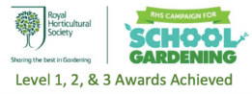
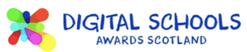

School Foreword

We are pleased to present both our Standards and Quality Report for Session 2021– 2022 and our School Improvement plan for the current session 2022 -2023. This report forms part of our quality improvement framework and provides important information regarding our school’s progress to date and identifies our next steps in school improvement.
Self-Evaluation for Self-Improvement is at the heart of our practice in Tough School. We continue to develop our practice in making robust use of evidence as a basis for judgements regarding the impact of our work on our learners.
How are we doing?
How do we know?
What are we going to do now?
Looking inwards to analyse our work
Looking outwards to find out more about what is working well for others locally and nationally
Looking forwards to gauge what continuous improvement might look like in the longer term
At Tough School we continue to be committed to working closely with our community and all other stakeholders that support the education we provide. Together we are working hard to ensure all our pupils get the best possible start in life and are enabled and encouraged to maximize their potential.
We realise that within education things never stand still or stay the same. We continue to strive to meet the changes and challenges. Through this document we hope that you will get a sense of our developments, successes, and areas for further growth.

Laura McAllister & Kerry Porter
Head Teachers

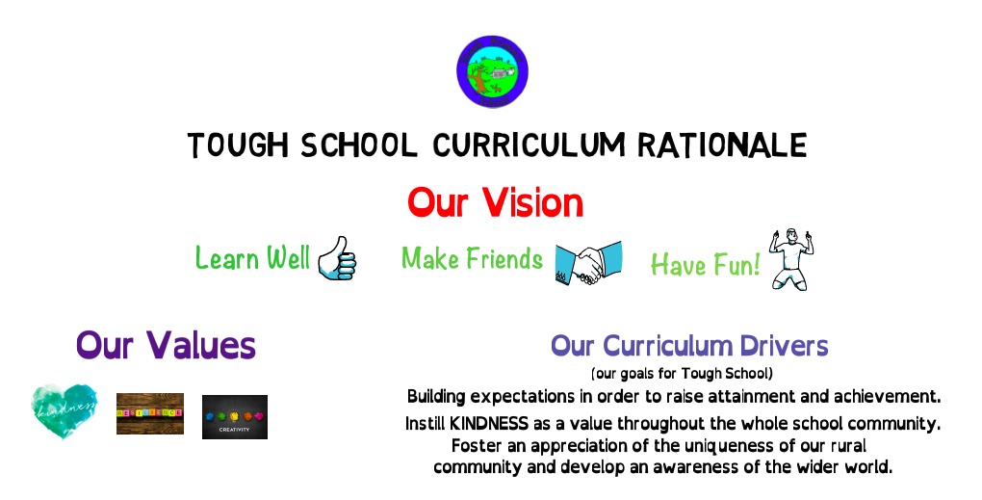

Vision for the school

Values that underpin our work

What do we aim to achieve for our children/pupils?

Context
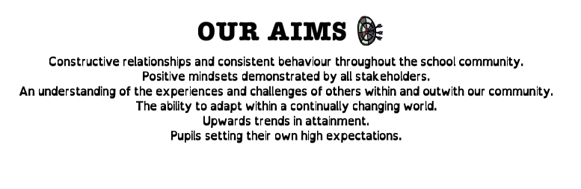

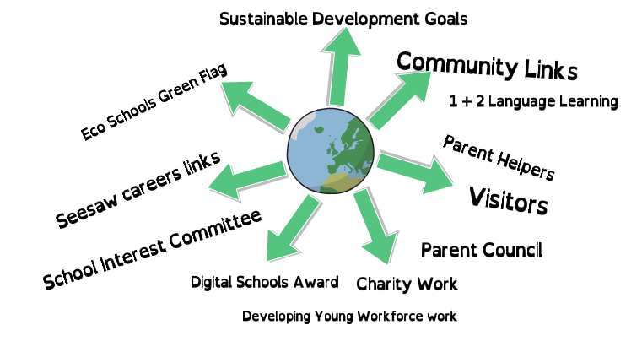
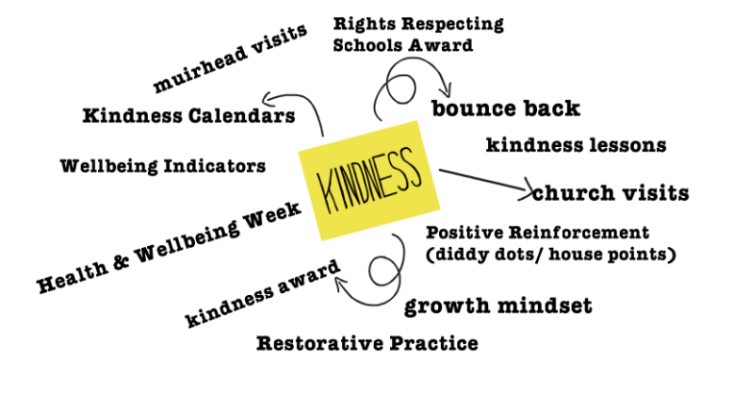

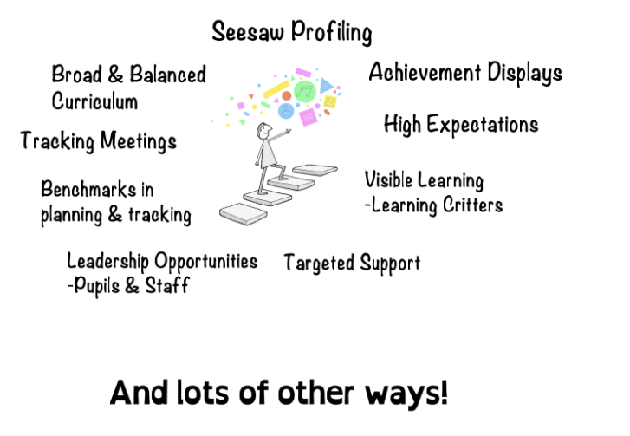

Impact of our developments
In this section we will outline the Targets we set last session and identify the progress we have made during session 2021-2022.
Key priority 2021-2022 | Key actions undertaken  Actions in red to move into 2022/23 | Impact (achieved throughout 2021-2022)
Learner Resilience in Maths | Pupil Maths Resilience Questionnaire.  Whole school to take part in Maths Week Scotland.  Resilience Maths mascot pupil homework challenge  Link careers to new topics in Maths.  Seesaw Maths focus.  Begin Growth Mindset whole school inputs, including Learning Critters and Learning Pit.  SEAL (Stages of Early Arithmetical Learning) training. LM/KP to attend and feed back to LS, HG and AMS.  Maths Anxiety and Resilience training. LM/KP to attend and feed back to LS, and AMS.  Maths Family Learning Challenge  Maths Open Afternoon  Community Maths Challenge goes out in post boxes and to businesses. | Maths resilience questionnaire results:  - ‘I enjoy maths’ increased from 88.2% to 100% for all/most/some of the time  - ‘I find maths fun’ increased from 82.4% to 88.2% for all/most some of the time  - ‘If I work hard at maths I can get better’ increased from 82.4% to 88.2% for agree/strongly agree.  - ‘I feel sad or worried about maths’ decreased from 23.5% to 17.6% for agree/strongly agree  - ‘I ask questions if I feel stuck’ increased from 94.1% to 100% for agree/strongly agree  Next steps for us are to continue to work on the idea of being ‘good at maths’ as this question saw a decrease from 64.7% to 52.9% for agree/strongly agree  Pupils and staff engaged well with Maths week activities  21 out of 22 pupils engaged in this homework activity and produced some excellent ideas. Having the designs made into a real soft toy was very motivational for our pupils and the winner’s parent chose to have one made up for a Christmas present too.  Seesaw posts helping to focus pupils on what they have been learning in maths when linking to careers and es and os  Pupils referring to growth mindset during maths learning conversations and linking this to our value of resilience  This scheduled training did not happen, we hope to do this in session 22/23  Family Sunflower challenge – pupils excited about measuring day. “My sunflower has grown lots” pupil comment  Maths Open afternoon will be in session 2022/23 due to covid constraints this session.  Community maths challenge to take place in 2022/23
Creativity including Play based learning | Speak to Caroline Brunton regarding Play Based Learning (PBL).  Trial PBL in P1-4.  Review PBL in P1-4.  PBL Inservice Day, including evaluating our learning environment against Realising the Ambition and our V, V & A, how to plan, assess and evaluate and start practitioner enquiry.  Begin PBL in P5-7.  Creativity Inservice Day.  “What is Creativity?” pupil poster.  Introduce the 4 Creativity Skills (curiosity, open-mindedness, imagination, problem solving) to learners, one per week. Share with parents through Seesaw.  Include Creativity Skills in weekly plans.  Immersive staff CPDs on Creativity Skills.  Create interactive Creativity Wall in GP Room.  Review PBL in both classes. | Information used to plan in-service day, consider next steps for us  Reading used to inform initial planning for P1-4.  Reviewed this on Inservice day when P1-4 teacher expressed that her confidence in allowing the pupils to play and discover more freely had hugely increased. Practitioner enquiry started.  Planning format developed for use in p1-4 and p5-7 alongside observation schedules.  Play video created by LS to clearly show the different aspects developed. We plan to share this with schools in our cluster in August.  Creativity In-service day highlighted how much creativity we use across all areas of our curriculum, especially in all aspects of play.  Most pupils can identify the 4 creativity skills and explain what they mean.  Creativity skills shared with parents on open afternoon.  Consideration given to the best place to include the creativity skills explicitly in planning – staff agree weekly plans are not the best way to show these. Possibly more useful in play planners – review this when reviewing play across the school.
Planning & Assessment | Use RSHP (Relationship, Sexual Health and Parenthood) resource to plan our Health and Wellbeing lessons. Incorporated into Forward Plans.  Purchase and share resources promoting Diversity to pupils and staff.  Diversity display in the library.  RRSA presentation and video created by pupils for parents.  Achieve RRS Silver Award | RSHP resources added into new plans on 2-year cycle. H & WB forward plans used across the school confidently. Teachers able to add in different activities to suit their learning and teaching. Staff comment “It’s so useful having all of the resources in one place.”  Pupils able to access a wider range of resources showing a diverse range of characters and choosing to pick from the new books provided.  Healthy Respect group presented to parents in assembly and gave out leaflets to let them know about Children’s Rights  Parent Comments:  “I didn’t realise there were so many articles in relation to children’s rights”  “It’s great to see children’s rights at the forefront. Well done!”  “Fantastic amount of work has been done to raise awareness of children’s rights – lovely to see!”  RRSA Silver Award assessment scheduled for early next session

How good is our leadership and approach to improvement?

QI 1.3 Leadership of change
Developing a shared vision, values and aims relevant to the school and its community
Strategic planning for continuous improvement
Implementing improvement and change
Relevant NIF priority: All
Relevant NIF driver(s): School leadership, Teacher professionalism, School improvement
Level of quality for core QI:
(HGIOS 4/HGIOELC 1-6 scale)

How well are you doing?
What’s working well for your learners?
- There is a very positive ethos within Tough School. All staff and all pupils can articulate the Vision and Values which are used in learning conversations, such as establishing and discussing class charter, restorative conversations, and Assemblies.
The Vision and Values are in line with GIRFEC and UNCRC and are embedded in our Curriculum Rationale and in the life of the school.
- The school has a clear Curriculum Rationale in place ensuring it reflects the uniqueness of our community. Staff and parents have an awareness of our Curriculum Rationale, particularly the Vision and Values.
- There are effective mechanisms in place to ensure that all families/carers are consulted in the life and work of the school, such as Seesaw, parent questionnaires, newsletters, whole school homework challenges, Parent Council and School Interest Committee.
- The school strives to engage with the local community to seek their views and ensure they have opportunities to contribute to school life and improvement, such as local future parent, Alex Standen, Snowsport Scotland’s Coaching Futures Coach, who came and taught our older pupils Nordic Skiing.
- We have engaged with local Police Scotland teams when our pupils took part in a traffic control operation outside our school.
- School community encouraged to visit a local gallery to see our Little Lighthouse, created in partnership with CLAN to support their Light the North Lighthouse trail.
- Teaching staff are effectively involved in school improvement planning, drawing on a wide range of evidence, such as HGIOS staff audit notes, assessment data, anecdotal evidence, parent and pupil surveys and Seesaw feedback. Almost all staff are involved in self-evaluation activities throughout the year and identify strengths and next steps.
- Tough School has a robust quality assurance calendar to ensure there is a focussed attention on monitoring and evaluating learning and teaching. There is consistency in practice across the school informed by our Learning, Teaching and Assessment policy.
- CPD opportunities are provided for all staff to access and link to improvement planning/next steps that have been identified.
- There have been opportunities for all teaching staff to engage in moderation practices both within our own school as well as opportunities across the cluster.
- There are opportunities for staff to take on leadership roles within Tough School, relating to School Improvement Priorities and Task Groups.
- All staff at Tough School know their children very well and are very much aware of the socio-economic context of the community. All staff continue to strive to ensure they are supportive and understanding of all families.
- Professional Review and Development (PRD) of all teaching staff conducted annually considering personal development needs and school improvement priorities with agreed targets to improve outcomes.
- Tough School works effectively with schools within their cluster to identify common areas for improvement.
How do you know?
What evidence do you have of positive impact on learners?
- Observed conversations of our pupils: Pupil 1 “Remember let everyone play. I don’t want to see anyone left out”. Pupil 2 “Yes that’s the school values” Pupil 1 “oh yeah, what are all the values again?” Pupil 2 “Okay, Creativity…” Pupil 1 “Oh yeah, and Kindness and Resilience, I remember!”
- Visit from Cluny staff member to see how play is set up and talk about next steps for them. LS visit to Craigievar to discuss play in their setting in P1-4.
- LS/KP writing moderation of a level.
- Healthy Respect Group presentation to parents in open afternoon – ready to be assessed for Silver RRS Award.
- Pupils in P7 becoming more confident in adding es and os and learning intentions on Seesaw and beginning to link their comments to careers.
- Teaching staff are keen to lead in an aspect/s of School Improvement, such as PE and play, making more aspects of improvement possible in teaching practice and school life.
- Conversations between HT and CT around tracking are purposeful and reflective, with next steps identified.
- Through purposeful Staff Meetings and regular informal professional dialogue, learners’ experiences are improved by all teaching staff moving forward and identifying aspects of improvement together.
- CPD training directly impacted all learner experience in Talk for Writing.
- All learners experience a cohesive and progressive curriculum, as evidenced through adapting of Forward Plans throughout the year/s.
- Staff moderation activities available give CTs assuredness that judgements on progress and practice are accurate.
- HT HGIOS Board.
- SIC clearly displayed with plans linked to SQUIP.
What are you going to do now?
What are your improvement priorities in this area?
- Share Curriculum Rationale with new parents.
- Go through QA calendar actions throughout year, from August onwards.
- Continue with Task Groups increase pupil voice opportunities formally.
- PPP carried out, as well as PRD meetings.
- Amend Homework Policy to include Seesaw.
- Parent open afternoons relating to pupils and SIP.
- Staff opportunities to lead in areas of learning, such as DYW.
- Review IDL and RME planning.
- P7 lunch clubs.
- Review observation schedule.
- Evaluate data more fully regarding School Improvement Priorities.
- Continue Joint Practitioner Enquiry regarding play-based learning.
- Update and share Teaching, Learning and Assessment Policy with stakeholders.
- Whole school lessons with Wee HGIOS. Begin to use Wee HGIOS questions in ‘forms’ with older pupils.

How good is the quality of care and education we offer?

QI 2.3 Learning, teaching and assessment
Learning and engagement
Quality of teaching
Effective use of assessment
Planning, tracking and monitoring
Relevant NIF priority: All
Relevant NIF driver(s): Teacher professionalism, School leadership, Parental engagement, Assessment of children’s progress
Level of quality for core QI: 4
(HGIOS 4/HGIOELC 1-6 scale)

How well are you doing?
What’s working well for your learners?
- The ethos of Tough School is warm, positive, nurturing and promotes mutually respectful relationships. Almost all pupils engage well with learning experiences, are eager to learn, motivated and involved.
- Through lessons, pupils have opportunities to lead learning and share their ideas.
- Differentiation and learner choice exists across all classes.
- All pupils are involved in self/peer assessment opportunities.
- Learning intentions and success criteria are well used to support pupils in their learning in Writing. This practice is consistent across the school. In all classes, pupils are involved in co constructing success criteria with staff in Writing.
- Talk for Writing approach continued and training took place for non-fiction texts.
- Through the Planning and Assessment Joint Practitioner Enquiry, teaching staff are using SC and LI in Maths and Literacy and LI in all other areas. These are shared with pupils as appropriate.
- Maths Mastery approaches has improved the quality of questions in Maths lessons in both classrooms.
- All pupils have regular opportunities to work individually, in pairs and in groups. All classes have opportunities to work with other classes for cross stage learning.
- All learning experiences are planned to match pupils needs/abilities.
- All staff use a variety of assessment approaches. This is improving with focus on assessment approaches in the Planning and Assessment Joint Practitioner Enquiry.
- All staff know their pupils very well and identify potential barriers quickly. These are discussed with HT to ensure timely action is taken to reduce barriers. HT communicates with ASL teacher to ensure appropriate support. Evidence of impact of interventions is sought in order to identify next steps.
- Almost all teaching staff have confidence in using a wide range of assessment data including standardised assessment results.
- Termly tracking supports pupils progress in learning.
- Digital technology is used to support learning across all classes.
- Parents/carers and pupils share learning through the use of a digital platform – Seesaw.
- All staff and pupils use a range of learning environments including the outdoors, the local woodland area.
- Wider achievements are recognised and celebrated through an annual survey and the Achievements Board. Achievements in school are celebrated through positive reward strategies.
How do you know?
What evidence do you have of positive impact on learners?
- Almost all learners are comfortable to come to staff to share views and speak out, knowing their voice is heard.
- When used with pupils, success criteria gives prompts for meaningful discussion and achievable targets making learning more accessible for all.
- Learners' expectations for themselves and their work at school is raised through self and peer assessment and through sharing work with parents through Seesaw.
- In Maths, in both classes, questioning has been more planned, as evidenced through weekly lesson plans.
- Conversations between HT and CT around tracking are purposeful and reflective, with next steps identified, including pastoral concerns.
- Pupils are motivated
- Parents show that their children value how we celebrate out of school achievements at Tough School through a variety of successes in activities out with school being sent through Seesaw and email.
- All pupils appear motivated by whole school positive reward strategies, e.g., diddy dots and house points.
- HT Office HGIOS Board.
What are you going to do now?
What are your improvement priorities in this area?
- Continue to run Task Groups to increase pupil voice formally.
- Continue Whole school lessons. Wee HGIOS and Values initial focus.
- Adapt observation schedule to include learner feedback on LI and SC.
- Continue Joint Practitioner Enquiry regarding play
- Maths Resilience and SEAL training through twilights.
- Update Literacy Policy to include Talk for Writing information.
- Learners co-constructing success criteria across all areas.
- LS lead in developments and lessons with the Learning Pit and Learning Critters, linking to maths resilience (Visible Learning).
- Develop maths plans to link CfE to White Rose resources
- All staff to attend Mark Burns and Shirley Clarke sessions on Inservice days
- Develop self and peer assessment across all areas of learning
- Restart four capacity awards at assemblies.

How good are we at improving outcomes for all our learners?

QI 3.1 Ensuring wellbeing, equality and inclusion
Wellbeing
Fulfilment of statutory duties
Inclusion and equality
Relevant NIF priority: All
Relevant NIF driver(s): Assessment of children’s progress, School improvement, Performance information
Level of quality for core QI:
(HGIOS?4/HGIOELC? 1-6 scale)
How well are you doing?
What’s working well for your learners?
- All staff at Tough School have a very good knowledge of learners, families and their community. A supportive ethos exists across the school for all pupils.
- All are fully committed to ensure everyone is treated equitably and with respect. Due to the dedication of all staff and pupils, they build very positive relationships, allowing staff to identify and support individual needs.
- Diversity is a continuing focus in our Development Plan.
- Library has been updated with a variety of diverse books.
- The school continues to maintain a link with the Pavilion Children’s Home in Kenya through links with the Gathimba Edwards Foundation. Our pupils write letters to members of the home to share experiences.
- The school follow a well-thought through Promoting Positive Behaviour Policy developed with other cluster schools. All staff have high expectations of behaviour with incidents dealt with promptly and effectively.
- All staff are clear on the policies and procedures around child protection. Staff are vigilant and prompt in highlighting concerns and responding to issues.
- All staff are clear on principles and processes in relation to GIRFEC. Almost all pupils have an awareness of the wellbeing indicators and can discuss these appropriately.
- All staff are aware of the UNCRC and understand that there are many articles involved in this. Teachers start the year with the creation of a whole class charter and the Healthy Respect group continue to teach younger pupils.
- Bounce Back is in use to promote the mental and emotional wellbeing of all learners.
- The school tracks pastoral wellbeing through tracking and monitoring discussions as well as surveys carried out with pupils.
- Curricular work, assemblies and wider community partnership encourage discussion, reflection and appreciation of faith, diversity and wellbeing.
- A range of universal supports are available in all classes.
- Clear procedures are in place to identify, assess and plan for pupils with additional support needs. IEPs, Managing Accessibility Plans (MAPs), and risk assessments are in place for individual pupils as appropriate and are developed with pupils, as appropriate, and parents to improve outcomes for learners.
- All pupils have chronologies in place. Pastoral notes are used on SEEMIS to support this. This includes a particular area to record any incident of alleged bullying.
- Termly tracking meetings with a member of the SLT and individual class teachers have a focus on pupils’ needs and discussion re targeted interventions. This supports the deployment of staff including Pupil Support Assistants (PSA) and ASL staff.
- Class teachers work closely with ASL teacher to plan targeted interventions. ASL teacher offers learning and teaching support, consultation, direct intervention. ASL teacher has good relationships with families and is pro-active in addressing next steps.
- Transition programmes and activities are in place for Early Years/Primary/Secondary to ensure the well-being of pupils. Transition meetings are held annually for ASN pupils involving previous and new teacher.
- £1000 grant for garden improvements to create a reflection area in the garden.
- Health and Well-being curricular forward plans in place.
- Introduction of knitted ‘Wellbeing Characters’ in our Zen Den for pupils to help familiarise pupils with the indicators.
How do you know?
What evidence do you have of positive impact on learners?
- Pupils are confident and have individuality, evidenced through day-to-day interactions.
- Attendance for all is above 83%.
- Promoting Positive Behaviour policy is cited and used in discussion with parents and staff, when appropriate. This ensures consistency for all learners.
- Low rate of playground and serious incidents being reported to HT over time, serious incidents dealt with out with normal class time emailed to HT to be filed
- Learners all see Tough Kirk as an important part of the community, even if they don’t go to church.
- Reading overlays are an example of successful and freely accessed aspects of universal support in class.
- IEPs and MAAPs show progression of individual targets over time.
- Pastoral aspects of tracking spreadsheet show progress of interventions, including ASL and PSA deployment.
- ASL teacher provides ILPs, including evaluations which show progress over time of individual pupils.
- Pupils and parents have identified that residential trips were extremely useful for establishing relationships between pupils from different schools and improving confidence in their children.
- Parent comments “Thank you so much, he had a brilliant time, all that worry for him on Monday night/tues morning for no reason!”
“The ski trip did him the world of good, he seems so confident since he came back!”
What are you going to do now?
What are your improvement priorities in this area?
- Whole school lessons relating to well-being indicators.
- Small year group transition programme in progress.
- Bounce Back survey at start and end of year.
- Implement Reflection Area in garden.
- Values input to whole school in Assemblies.
- Review Seesaw post quality at start of session.
- RRS Silver Award accreditation
- Health and Wellbeing policy to be written.
- Video call with children in Pavilion Home

QI 3.2 Raising attainment and achievement
Attainment in literacy and numeracy
Attainment over time
Overall quality of learners’ achievement
Equity for all learners
Relevant NIF priority: All
Relevant NIF driver(s): Assessment of children’s progress, School improvement, Performance information
Level of quality for core QI:
(HGIOS?4/HGIOELC? 1-6 scale)
How well are you doing?
What’s working well for your learners?
- Attainment review with Cluster HTs regularly undertaken.
- There is a positive picture of attainment for Tough School.
  - Almost all learners (91%) are achieving appropriate progress, expected levels or exceeding expectations in Writing.
  - Almost all learners (95%) are achieving appropriate progress, expected levels or exceeding expectations in Reading.
  - Almost all learners (91%) are achieving appropriate progress, expected levels or exceeding expectations in Numeracy.
- Universal supports are in place and targeted interventions for identified pupils and groups are put in place for those who need support.
- The school has a robust TMR system in place which is discussed termly with staff to ensure individual pupil progress is tracked. Next steps are clearly identified and planned for. Interventions are also regularly reviewed for impact.
- All staff have a good understanding of expected standards in literacy and numeracy supported by the national benchmarks and E&Os.
- Pupil Equity Funding has been used to support the development of:
- Creativity and Play
- Diversity
- Forest Schools to improve Health and Wellbeing
- All pupils are successful, confident and responsible almost all the time. They contribute to the life and work of the school. Their opinions are sought and acted upon allowing them ownership of initiatives and their school community, such as CLAN Little Lighthouse and Home Learning Survey. All pupils are involved in whole school development groups and pupil voice forms part of self-evaluation activities.
- Out-of-school and in-school achievements are recognised and shared across the school. The school track this information (found in Tracking) to ensure identification of any pupil at risk of missing out.
- Attendance levels are generally high, exclusion rates are low, and inclusion is successful for most pupils.
How do you know?
What evidence do you have of positive impact on learners?
- HTs reassured of sound professional judgements through discussion and moderation with other HTs, making any curricular changes for the learners well informed.
- Tracking spreadsheet shows progress over time in Literacy, Numeracy and pastoral concerns.
- ASL teacher provides ILPs, including evaluations which show progress over time of individual pupils.
- Using benchmarks in tracking and monitoring discussions make these standards relevant to the learners.
- Attendance recorded through Seemis is generally high. Any anomalies of this are tracked and support offered.
- Improvement in levels across the school for all curricular areas compared to last session.
- Staff have observed a change in how confidently our pupils play and choose different activities when learning at PEF funded Forest Schools sessions. They are able to easily recall safety rules and play imaginatively in a change from our initial FS sessions.
What are you going to do now?
What are your improvement priorities in this area?
- Pupil participation in wider community.
- Review use of Seesaw to ensure consistency across the school.
- Minutes of Task Groups sessions for all groups
- Review RRK as a tool for recording IDL alongside new play planners.
- Forest Schools to continue with a variety of pupil led activities. This will also support children unable to attend clubs and groups out with school.
- P7 lunch clubs in Term 3.

PEF 2022-2023

Identified gap | - Some pupils lack opportunities for achievement outside of school, contributing to Health and Wellbeing.  - No PSA cover at lunch breaks will be a substantial change for our pupils. They will have to put our school values at the forefront, especially Resilience.  - The rural location of our school means that all of our pupils do not often experience a wide range of diversity in the community.
Expenditure | Details FTE/Hours/ No. Cost 2022/23  Resources/Equipment/ Materials Signage/spaces in our playground for reflection Resources to promote diversity in play Equality/Diversity Award costs £150 £150 £395  Commissioned/purchased services/partners Forest schools level 3 trained professional delivered sessions – 4 per class=8 total £1120  Total (inc Carry Forward) £1816
Expected outcomes | Diversity Resources  - Our learners are able to appreciate the diversity of the wider world out with our close community and can challenge stereotypes and assumptions.  - All pupils understand and can talk about Children’s rights, in particular articles 1, 14, 13, 19 and 30.  Resilience  - No increase in issues in the playground on days when a PSA is not outside. Pupils able to deal sensibly with situations that arise and offer solutions.  Forest Schools  - Forest School aims to promote the holistic development of all those involved, fostering resilient, confident, independent and creative learners  - Forest School takes place in a woodland or natural wooded environment to support the development of a relationship between the learner and the natural world.
Impact Measurements | Impact of Diversity Resources  Will be measured through  - Observations of language used in play, especially small world and imaginative  - Conversations in assemblies  - Task group questionnaires  Impact of Resilience Work  - Observations of interactions in the playground by HT  - Conversations in the classroom recognising when resilience was shown in the playground  - Observations on how many incidents must be dealt with by a member of staff. Restorative conversations needed to suggest ways of using resilience skills.  Impact of Forest Schools  Will be measured mainly through observations of  - How our pupils adapt to a different learning environment.  - How our learners cooperate in a variety of activities.  - What skills and attitudes our learners bring back into the classroom with them.  - How our learners’ social skills develop.  - How confidence improves in specific learners, especially our FSM pupils.  - How effectively our learners become involved in planning for learning and using their own opinions and ideas.

Capacity for improvement

School staff are fully committed to the principle of continuous improvement. We wish to provide the very best for every child in our care. In this task, we are increasingly advised by performance data, such as pupil attainment data, so we can see clearly ‘what’ we need to improve.
We will continue to look inwards, outwards and forwards to prepare and equip our young people for their future. We will continue to work in partnership with parents, health professionals, and others to ‘get it right’ for every child.

Action Plan 1
National Improvement Framework Priorities | HGIOS and ELCC  1.1 Self-evaluation for self-improvement  1.2 Leadership for learning  1.3 Leadership of change  1.4 Leadership and management of staff/ practitioners  1.5 Management of resources to promote equity  2.1 Safeguarding and child protection  2.2 Curriculum  2.3 Learning teaching and assessment  2.4 Personalised support  2.5 Family learning  2.6 Transitions  2.7 Partnerships  3.1 Improving/ ensuring wellbeing, equality and inclusion  Specific to HGIOS 4  3.2 Raising attainment and achievement  3.3 Increasing creativity and employability  Specific to HGIOELC  3.2 Securing children’s progress  3.3 Developing creativity and skills for life |  |  |  | Aberdeenshire Priorities:  1. Improving learning, teaching and assessment.  2. Partnership working to raise attainment.  3. Developing leadership at all levels.  4 Improvement through self-evaluation.
- Improvement in attainment, particularly in literacy and numeracy.
- Closing the attainment gap between the most and least disadvantaged children.
- Improvement in children and young people’s health and wellbeing.
- Improvement in employability skills and sustained, positive destinations.
Key drivers of improvement
School leadership

Teacher professionalism

Parental engagement

Assessment of children’s progress

School improvement

Performance Information
Priority 1: Embed creativity including play across learning making links to DYW, encouraging entrepreneurship and innovation. This will also give opportunities to continue work on Maths resilience. |  |  | Data/evidence informing priority:  Improvement in skills and sustained, positive school-leaver destinations for all young people is a NIF key priority  Pupils find it difficult to identify a wide range of careers when making links through Seesaw.
Key actions |  | By whom |  | When? | How will we evaluate impact?  (Measurements of success) | Progress
 |  |  |  |  |  | On Track
 |  |  |  |  |  | Behind Schedule
 |  |  |  |  |  | Not Achieved
- Creativity Assessment posters ‘What is creativity’ – all pupils  - Creativity Skills added to plans where appropriate  - Staff engaging in the Careers Education Standard.  Begin with audit in September  - Consistency in Seesaw profiling linking to maths learning and careers  - Whole school take part in Maths Week Scotland  - Interactive creativity display in hall  - My world of work website used by the P5-7 pupils.  - Review play across the school  - Moderation of play practise with cluster schools. LS to share development work  - Enterprise ‘grow a fiver’ type activities planned to raise money for Gathimba Edwards Foundation, a charity the school already has links with.  - Visible learning linked to growth mindset work and maths resilience – learning critters/learning pit  - Career fairs to be held in collaboration with mini-cluster schools. |  | All teaching staff  All teaching staff  KP/LM  All teaching staff  All teaching staff  LM/KP  KP  All staff  Teaching staff  KP/LM Teaching staff  LS  All teaching staff |  | Aug ‘22  Sept ‘22  Sept ’22 onwards  Sept ’22 onwards  Sept ‘22  Oct ‘22  Nov ’22  Nov ‘22  Dec ‘22  Feb ‘23  Feb ‘23  May ‘23 - dates tbc | Posters show a greater understanding of creativity from those created in 21/22 session  Staff including creativity skills effectively in planning  Entitlements & Expectations from CES used to audit where we are in Sept ‘22 and June ‘23  Clearer links to learning and careers in Seesaw posts  Engagement in tasks Feedback from parents and pupils  Pupils asking to add work examples of creativity to the display, identifying skills used  Pupils can talk about a wide range of careers. Older pupils can identify different pathways to work.  Staff observations of play can identify and evidence creativity skills in action  Conversations and feedback from staff in other cluster schools and reflections on own practise.  Pupils able use creativity skills to help plan and implement their enterprise.  Pupils able to describe the learning pit and how they can face challenges  Pupil/parent feedback

Action Plan 2
National Improvement Framework Priorities | HGIOS and ELCC  1.1 Self-evaluation for self-improvement  1.2 Leadership for learning  1.3 Leadership of change  1.4 Leadership and management of staff/ practitioners  1.5 Management of resources to promote equity  2.1 Safeguarding and child protection  2.2 Curriculum  2.3 Learning teaching and assessment  2.4 Personalised support  2.5 Family learning  2.6 Transitions  2.7 Partnerships  3.1 Improving/ ensuring wellbeing, equality and inclusion  Specific to HGIOS 4  3.2 Raising attainment and achievement  3.3 Increasing creativity and employability  Specific to HGIOELC  3.2 Securing children’s progress  3.3 Developing creativity and skills for life |  |  |  | Aberdeenshire Priorities:  1. Improving learning, teaching and assessment.  2. Partnership working to raise attainment.  3. Developing leadership at all levels.  4 Improvement through self-evaluation.
- Improvement in attainment, particularly in literacy and numeracy.
- Closing the attainment gap between the most and least disadvantaged children.
- Improvement in children and young people’s health and wellbeing.
- Improvement in employability skills and sustained, positive destinations.
Key drivers of improvement
School leadership

Teacher professionalism

Parental engagement

Assessment of children’s progress

School improvement

Performance Information
Priority 2: To improve and develop teaching and learning in Diversity and Equality |  |  | Data/evidence informing priority:  Our pupils currently experience a limited amount of diversity within our rural community  Through discussion with our pupils while sharing diversity books we found lots of questions and new conversations arose which gives up opportunities to develop understanding of diversity and equality further.
Key actions |  | By whom |  | When? | How will we evaluate impact?  (Measurements of success) | Progress
 |  |  |  |  |  | On Track
 |  |  |  |  |  | Behind Schedule
 |  |  |  |  |  | Not Achieved
- Assessment for RRS Silver Award  - Assemblies with Diversity/Equality as a focus – use UNCRC and SDGs to support learning. Include gender imbalance across careers.  - Parent Questionnaire on Diversity/Equality in our school  - Equalities Award  - Investigate and start to work towards Equalities award  - Engagement with LGBT schools charter (if authority choose to bring this forward)  - Comprehensive RME planners developed in partnership with mini-cluster schools |  | KP  KP/LM  KP/LM  KP/LM all staff  All staff  All staff/KP |  | Sept ‘22  Oct ‘22  Jan ‘23  Feb ‘23  March ‘23  June ‘23 | Achievement of award and feedback from assessor  Discussions with pupils, observations of language used  Feedback from Parents on progress/next steps  Successful progress through programme  Progress through the award stages  Implementation of plans and feedback from staff

Action Plan 3
National Improvement Framework Priorities | HGIOS and ELCC  1.1 Self-evaluation for self-improvement  1.2 Leadership for learning  1.3 Leadership of change  1.4 Leadership and management of staff/ practitioners  1.5 Management of resources to promote equity  2.1 Safeguarding and child protection  2.2 Curriculum  2.3 Learning teaching and assessment  2.4 Personalised support  2.5 Family learning  2.6 Transitions  2.7 Partnerships  3.1 Improving/ ensuring wellbeing, equality and inclusion  Specific to HGIOS 4  3.2 Raising attainment and achievement  3.3 Increasing creativity and employability  Specific to HGIOELC  3.2 Securing children’s progress  3.3 Developing creativity and skills for life |  |  |  | Aberdeenshire Priorities:  1. Improving learning, teaching and assessment.  2. Partnership working to raise attainment.  3. Developing leadership at all levels.  4 Improvement through self-evaluation.
- Improvement in attainment, particularly in literacy and numeracy.
- Closing the attainment gap between the most and least disadvantaged children.
- Improvement in children and young people’s health and wellbeing.
- Improvement in employability skills and sustained, positive destinations.
Key drivers of improvement
School leadership

Teacher professionalism

Parental engagement

Assessment of children’s progress

School improvement

Performance Information
Priority 3: To ensure safe and appropriate use of technology is embedded across the school while developing the use of technology to support and enhance learning and teaching across the curriculum. |  |  | Data/evidence informing priority:  Incidents have occurred out with school that we have addressed in school and we want to ensure we have a consistent and effective approach that also supports families.  We want to be confident that our learners aware of the potential harm when interacting with the online community and have strategies and tools to deal with issues that they may experience.
Key actions |  | By whom |  | When? | How will we evaluate impact?  (Measurements of success) | Progress
 |  |  |  |  |  | On Track
 |  |  |  |  |  | Behind Schedule
 |  |  |  |  |  | Not Achieved
- Ensure Cyber Resilience and Internet Safety experiences and outcomes are included in our Health and Wellbeing plans, ensuring clear and progressive planning, and appropriate coverage and depth of learning  - Comprehensive resource list created to accompany plans  - Review coverage of CRIS in learning and teaching  - Work towards Digital Schools Cyber Resilience award  - Parent open afternoon – CRIS and pupils sharing learning and advice  - Continue to develop digital technology skills across the whole school |  | KP and teaching staff  KP  KP/whole staff  KP/whole staff  Whole school/KP  All teaching staff |  | Dec ‘22  Dec ‘22  Feb ‘23  Aug - April ‘22  June ’23  Oct ‘22 | Effective use of Health & Wellbeing plans.  Staff review use of plans and resources  Staff Discussion  Progress towards CRIS award  Progress through award criteria  Parental Feedback  Increased confidence and independence in using a variety of software. Staff engagement with CLPL

Wider Achievements
Completed pupil survey this year and celebrated through the Wider Achievement Board. A tracking spreadsheet will be created this year to monitor over time.
Wider Community Links
See above.

