Tough Primary School

School Badge/Aberdeenshire logo

Standards & Quality Report
2022 - 2023
&
School Improvement Planning
2023 -2024

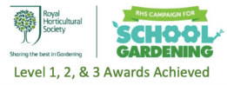
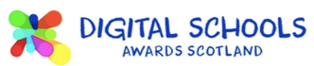

School Foreword

We are pleased to present both our Standards and Quality Report for Session 2022– 2023 and our School Improvement plan for the current session 2023 -2024. This report forms part of our quality improvement framework and provides important information regarding our school’s progress to date and identifies our next steps in school improvement.
Self-Evaluation for Self-Improvement is at the heart of our practice in Tough School. We continue to develop our practice in making robust use of evidence as a basis for judgements regarding the impact of our work on our learners.
How are we doing?
How do we know?
What are we going to do now?
Looking inwards to analyse our work
Looking outwards to find out more about what is working well for others locally and nationally
Looking forwards to gauge what continuous improvement might look like in the longer term
At Tough School we continue to be committed to working closely with our community and all other stakeholders that support the education we provide. Together we are working hard to ensure all our pupils get the best possible start in life and are enabled and encouraged to maximize their potential.
We realise that within education things never stand still or stay the same. We continue to strive to meet the changes and challenges. Through this document we hope that you will get a sense of our developments, successes, and areas for further growth.

Laura McAllister & Kerry Porter
Head Teachers

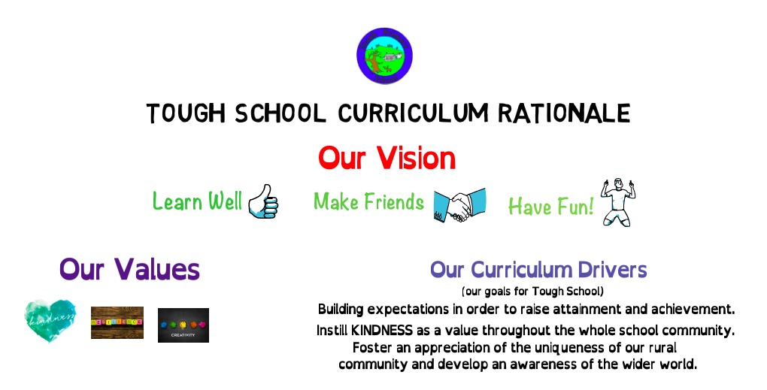

Vision for the school

Values that underpin our work

What do we aim to achieve for our children/pupils?

Context
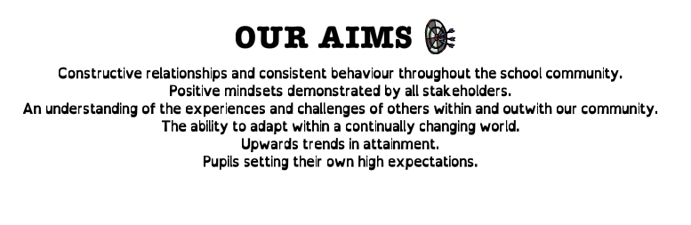

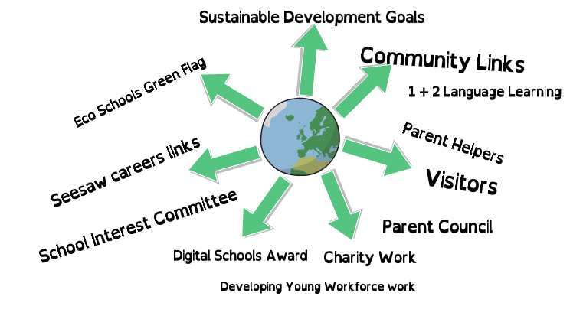
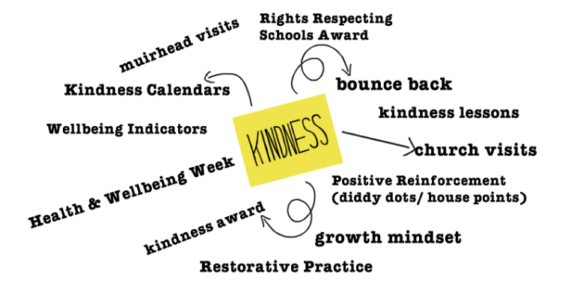

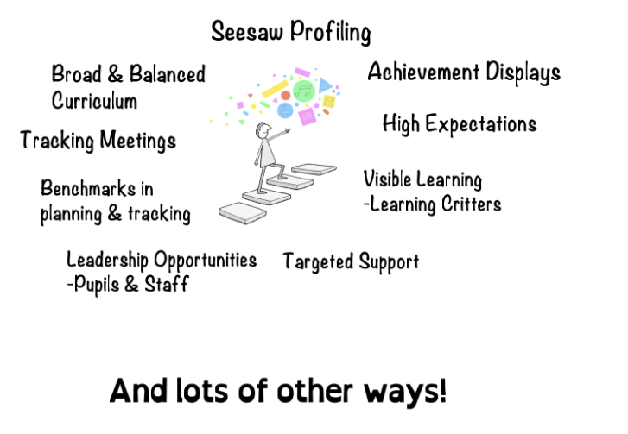

Impact of our developments
In this section we will outline the Targets we set last session and identify the progress we have made during session 2021-2022.
Key priority 2022 - 2023 | Key actions undertaken  Actions in red to move into 2023/24 | Impact (achieved throughout 2022-2023)
Embed creativity across the curriculum | Seesaw posts relating to Maths to be consistent and linked to careers.  What is Creativity assessment posters.  Creativity Skills added to plans. In both classes these were added to Play Planners.  Whole school took part in Maths Week Scotland.  Careers Education Skills audit.  Interactive Maths display.  Review Play Based Learning across the school.  P5-7 use My World of Work  Maths training.  Moderation of play developments with cluster schools. Visits to other schools and from other schools.  Maths Open Afternoon  Community Maths Challenge.  Grow a Fiver.  Interactive creativity display.  Cross-cluster careers fair. | In P5-7 the quality of Seesaw posts was consistently improved with posts relating to Maths in terms of layout.  In P1-4 Seesaw posts were utilised to share group activities.  Seesaw use suspended in December 2022.  All P2-7 children are much more aware of the Creativity Skills across the curriclulum, rather than just in the Expressive Arts.  Teachers are reminded of these every time they plan their play.  Feedback from pupils was positive, improving attitude to Maths, with displays created and enjoyed by all pupils.  Huge mindset shift across all teaching staff with giving children ownership of their play experiences. Shown by staff being able to readily talk about Creativity Skills demonstrated through play.  Resource reviewed and not used in P5-7 due to appropriateness to our target.  Confidence of LS much improved in order to speak about her practise of using play in her classroom.  Shared understanding across Alford Cluster of how Tough uses play in practise.  Parent comments:  “Really good, very interesting.”  “Very interesting. Informative. Good to see equipment used.”  “Thankyou for a great afternoon. Lovely to see all the Maths activities that the children take part in.”  “Very interesting!”  “Fabulous interactive activities. Thankyou!”  Pupil comment:  “More pizza!”  Reacted to changes in SIC over the year and prioritised Maths.
Diversity and Equality | RRS Silver Award accreditation.  Whole school assemblies  Visits to Muirhead Care Home.  Parent questionnaire to Equality and Diversity.  Equalities Award  Review RME planners  Engagement with LGBT Schools Charter  Racial Literacy training | Achievement of award and very positive feedback from assessor.  Comments included: All children interviewed ranging from P1 to P7 were familiar with a range of articles. They knew that rights were unconditional and universal. One child stated when asked if they needed to do anything to access their rights that “We don’t need to do anything, just be born.”. When they were asked to describe what a right was one child said, “They are things adults have to make sure we have to keep us safe and happy”.  Children in P5-7 take part in mature discussions to do with learning conditions and race. Also they have shown themselves able to think beyond their own lived experience are provided.  Unaffordable for a small school. Access granted to trial Equaliteach website and resources. Resources used for staff training during February Inservice and staff awareness/confidence improved to carry out class activities which followed.  Survey used with P5-7 pupils which prompted much mature conversation and questioning. Results showed LGBT education to be a main area for improvement.  KP has completed Building Racial Literacy training provided by Education Scotland. Her confidence and understanding of racism and the need to be anti-racist has hugely improved. This will be shared during Staff Development time.
Developing use of technology, including cyber resilience and internet safety | Self-assessment with staff and pupils.  Staff engaging in digital technologies CPD. This included iPads for PSAs, Apple Leadership, Microbits, Dash and Dot, Evolving Digital Thinking.  Whole school community use 360° Safe Scotland self-review toolkit.  CRIS added to H and WB plans including resource links.  Review technologies coverage in curriculum.  Apply Digital Schools Cyber Resilience Award.  Parent Open Afternoon on Cyber Resilience and Internet Safety. | Dash and Dot used across in play in both classes and at Maths Open Afternoon. Parents and children enjoyed together.  Bluebots used at Maths Open Afternoon which parents and children enjoyed together.  Microbits used in P5-7 and children’s knowledge and attitude to resource was positive.  Cyber resilience award resources will be utilised instead. KP will complete 360° review.  H and WB plans fit for purpose and ensure cyber resilience embedded in our curriculum.

How good is our leadership and approach to improvement?

QI 1.3 Leadership of change
Developing a shared vision, values and aims relevant to the school and its community
Strategic planning for continuous improvement
Implementing improvement and change
Relevant NIF priority: All
Relevant NIF driver(s): School leadership, Teacher professionalism, School improvement
Level of quality for core QI: 4
(HGIOS 4/HGIOELC 1-6 scale)

How well are you doing?
What’s working well for your learners?
- There is a very positive ethos within Tough School. All staff and all pupils can articulate the Values which are used in learning conversations, such as establishing and discussing class charter, restorative conversations, and Assemblies.
- The Values are in line with GIRFEC and UNCRC and are embedded in our Curriculum Rationale and in the life of the school.
- The school has a clear Curriculum Rationale in place ensuring it reflects the uniqueness of our community. Staff and parents have an awareness of our Curriculum Rationale, particularly the Vision and Values.
- There are effective mechanisms in place to ensure that all families/carers are consulted in the life and work of the school, such as Marvellous Me, parent questionnaires, newsletters, open afternoons, Facebook Page, Parent Council and School Interest Committee.
- The school strives to engage with the local community to seek their views and ensure they have opportunities to contribute to school life and improvement, such as River Dee Trust to investigate our local watercourse and Bumps, Bairns and Buggies top learn about looking after a baby.
- We have engaged local ROV pilot, Gregor Young, when learning more about the Titanic and a career as an ROV pilot.
- School community encouraged to visit local Forestry Commission walks at Bennachie to view our Big Hop Trail leveret created in partnership with CLAN.
- Visited local landmark in P1-4, Castle Fraser to learn about living in a castle.
- The whole school achieved the Silver Rights Respecting School Award with the whole school community supporting.
- There are strong links with our local church at Tough. These include an annual moral award, regular visits to the church and visits from Simon, the minister.
- Teaching staff are effectively involved in school improvement planning, drawing on a wide range of evidence, such as HGIOS staff audit notes, assessment data, anecdotal evidence and parent and pupil surveys. All staff are involved in self-evaluation activities throughout the year and identify strengths and next steps.
- Tough School has a robust quality assurance calendar to ensure there is a focussed attention on monitoring and evaluating learning and teaching. There is consistency in practice across the school informed by our Learning, Teaching and Assessment policy.
- CPD opportunities are provided for all staff to access and link to improvement planning/next steps that have been identified.
- There have been opportunities for all teaching staff to engage in moderation practices both within our own school as well as opportunities across the cluster and beyond. This has particularly involved play based pedagogy this session and visits from practitioners and contributing to the Scottish Learning Festival.
- There are opportunities for staff to take on leadership roles within Tough School, relating to School Improvement Priorities and Task Groups.
- All staff at Tough School know their children very well and are very much aware of the socio-economic context of the community. All staff continue to strive to ensure they are supportive and understanding of all families.
- Professional Review and Development (PRD) of all teaching staff conducted annually considering personal development needs and school improvement priorities with agreed targets to improve outcomes.
- PPP meetings take place annually with Administrative and Pupil Support Staff.
- Tough School works effectively with schools within their cluster to identify common areas for improvement.
How do you know?
What evidence do you have of positive impact on learners?
- Visits from Cluny, Echt, Towie, Dunecht, Craigievar and Skene staff members to see how play is set up and talk about next steps for them. Midmar to visit next session.
- KP and LM took part in writing assessment moderation.
- Healthy Respect Group and whole school achieved Silver Rights Respecting School Award. The RRSA assessor recommended we go for gold soon. Parent comments included:
“A fantastic amount of work has been done to raise awareness of children’s rights.”
“My child is very aware of rights and situations where others may not be able to access their rights.”
“I think the work on children’s rights has helped develop a greater sense of empathy for others and an understanding that life is not the same for everyone.”
“The children feel valued at school and they feel heard in discussions.”
Pupil quotes included:
“We don’t need to do anything (to access rights). Just be born.”
“(Rights) are things adults have to make sure that we are safe and happy.”
- Teaching staff are keen to lead in an aspect/s of School Improvement, such as play, making more aspects of improvement possible in teaching practice and school life.
- Conversations between HT and CT around tracking are purposeful and reflective, with next steps identified through use of benchmarks.
- Through purposeful Staff Meetings and regular informal professional dialogue, learners’ experiences are improved by all teaching staff moving forward and identifying aspects of improvement together.
- All learners experience a cohesive and progressive curriculum, as evidenced through adapting of Forward Plans throughout the year/s.
- Staff moderation activities available give CTs assuredness that judgements on progress and practice are accurate.
- HT HGIOS Board.
- SIC clearly displayed with plans linked to SQUIP.
What are you going to do now?
What are your improvement priorities in this area?
- Update School Vision with whole school community.
- Go through QA calendar actions throughout year, from August onwards.
- Continue with Task Groups increase pupil voice opportunities formally.
- Parent open afternoons relating to pupils and SIP.
- Staff opportunities to lead in areas of learning, such as IDL.
- Review IDL and RME planning.
- P7 lunch clubs.
- Joint Practitioner Enquiry regarding IDL or Expressive Arts.
- Continue whole school lessons with Wee HGIOS.

How good is the quality of care and education we offer?

QI 2.3 Learning, teaching and assessment
Learning and engagement
Quality of teaching
Effective use of assessment
Planning, tracking and monitoring
Relevant NIF priority: All
Relevant NIF driver(s): Teacher professionalism, School leadership, Parental engagement, Assessment of children’s progress
Level of quality for core QI: 4
(HGIOS 4/HGIOELC 1-6 scale)

How well are you doing?
What’s working well for your learners?
- The ethos of Tough School is warm, positive, nurturing and promotes mutually respectful relationships. Almost all pupils engage well with learning experiences, are eager to learn, motivated and involved.
- Through lessons, pupils have opportunities to lead learning and share their ideas.
- Differentiation and learner choice exists across all classes. This has particularly improved this Session through play based pedagogy in P1-4.
- All pupils are involved in self/peer assessment opportunities.
- Learning intentions and success criteria are well used to support pupils in their learning in Writing. This practice is consistent across the school. In all classes, pupils are involved in co constructing success criteria with staff in Writing.
- LI and SC are included in weekly plans across the school for all areas of literacy and numeracy. These are shared with pupils as appropriate.
- All pupils have regular opportunities to work individually, in pairs and in groups. All classes have opportunities to work with other classes for cross stage learning.
- All learning experiences are planned to match pupils needs/abilities.
- All staff use a variety of assessment approaches.
- All staff know their pupils very well and identify potential barriers quickly. These are discussed with HT to ensure timely action is taken to reduce barriers. HT communicates with ASL teacher to ensure appropriate support. Evidence of impact of interventions is sought in order to identify next steps.
- All teaching staff have confidence in using a wide range of assessment data including standardised assessment results.
- Termly tracking supports pupils progress in learning.
- Digital technology is used to support learning across all classes.
- Parents/carers and pupils share learning through the use of a digital platform – Marvellous Me and Facebook. This will be further developed next Session.
- All staff and pupils use a range of learning environments including the outdoors, the local woodland area.
- Wider achievements are recognised and celebrated through an annual survey and the Achievements Board and they’re shared in Assemblies. Achievements in school are celebrated through positive reward strategies.
How do you know?
What evidence do you have of positive impact on learners?
- Almost all learners are comfortable to come to staff to share views and speak out, knowing their voice is heard.
- When used with pupils, success criteria gives prompts for meaningful discussion and achievable targets making learning more accessible for all.
- Learners' expectations for themselves and their work at school is raised through self and peer assessment and through sharing work with parents through Marvellous Me.
- Conversations between HT and CT around tracking are purposeful and reflective, with next steps identified, including pastoral concerns.
- Pupils are motivated.
- Parents show that their children value how we celebrate out of school achievements at Tough School through a variety of successes in activities out with school being sent through email.
- All pupils appear motivated by whole school positive reward strategies, e.g., diddy dots and house points.
- HT Office HGIOS Board.
What are you going to do now?
What are your improvement priorities in this area?
- Continue to run Task Groups.
- Continue Whole school lessons. Wee HGIOS and Vision initial focus.
- Begin joint practitioner enquiry regarding IDL or expressive arts.
- Continue whole school developments within equality and diversity to ensure inclusive education for all.
- Add protected characteristics to our Promoting Positive Behaviour Policy.
- Learners co-constructing success criteria across all areas.
- LS lead in developments in IDL.
- Develop maths plans to link CfE to White Rose resources.

How good are we at improving outcomes for all our learners?

QI 3.1 Ensuring wellbeing, equality and inclusion
Wellbeing
Fulfilment of statutory duties
Inclusion and equality
Relevant NIF priority: All
Relevant NIF driver(s): Assessment of children’s progress, School improvement, Performance information
Level of quality for core QI:
(HGIOS?4/HGIOELC? 1-6 scale)
How well are you doing?
What’s working well for your learners?
- All staff at Tough School have a very good knowledge of learners, families and their community. A supportive ethos exists across the school for all pupils.
- All are fully committed to ensure everyone is treated equitably and with respect. Due to the dedication of all staff and pupils, they build very positive relationships, allowing staff to identify and support individual needs.
- Diversity is a continuing focus in our Development Plan.
- Library has been updated with a variety of diverse books.
- The school continues to maintain a link with the Pavilion Children’s Home in Kenya through links with the Gathimba Edwards Foundation. Our pupils write letters to members of the home to share experiences.
- The school follow a well-thought through Promoting Positive Behaviour Policy developed with other cluster schools. All staff have high expectations of behaviour with incidents dealt with promptly and effectively.
- All staff are clear on the policies and procedures around child protection. Staff are vigilant and prompt in highlighting concerns and responding to issues.
- All staff are clear on principles and processes in relation to GIRFEC. Almost all pupils have an awareness of the wellbeing indicators and can discuss these appropriately.
- All staff are aware of the UNCRC and understand that there are many articles involved in this. Teachers start the year with the creation of a whole class charter and the Healthy Respect group continue to teach younger pupils.
- Bounce Back is in use to promote the mental and emotional wellbeing of all learners.
- The school tracks pastoral wellbeing through tracking and monitoring discussions as well as surveys carried out with pupils.
- Curricular work, assemblies and wider community partnership encourage discussion, reflection and appreciation of faith, diversity and wellbeing.
- A range of universal supports are available in all classes.
- Clear procedures are in place to identify, assess and plan for pupils with additional support needs. IEPs and risk assessments are in place for individual pupils and are developed with pupils, as appropriate, and parents to improve outcomes for learners.
- All pupils have chronologies in place. Pastoral notes are used on SEEMIS to support this. This includes a particular area to record any incident of alleged bullying.
- Termly tracking meetings with a member of the SLT and individual class teachers have a focus on pupils’ needs and discussion re targeted interventions. This supports the deployment of staff including Pupil Support Assistants (PSA) and ASL staff.
- Class teachers work closely with ASL teacher to plan targeted interventions. ASL teacher offers learning and teaching support, consultation, direct intervention. ASL teacher has good relationships with families and is pro-active in addressing next steps.
- Transition programmes and activities are in place for Early Years/Primary/Secondary to ensure the well-being of pupils. Transition meetings are held annually for ASN pupils involving previous and new teacher.
- Health and Well-being curricular forward plans in place.
- Whole school Kindness Lessons delivered by all teaching staff.
- Fortnightly assemblies with a diversity focus.
How do you know?
What evidence do you have of positive impact on learners?
- Pupils are confident and have individuality, evidenced through day-to-day interactions.
- Attendance for all is above 85%. Average attendance across the school is 95%.
- Promoting Positive Behaviour policy is cited and used in discussion with parents and staff, when appropriate. This ensures consistency for all learners.
- Learners all see Tough Kirk as an important part of the community, even if they don’t go to church.
- Reading overlays are an example of successful and freely accessed aspects of universal support in class.
- IEPs show progression of individual targets over time.
- Pastoral aspects of tracking spreadsheet show progress of interventions, including ASL and PSA deployment.
- ASL teacher provides ILPs, including evaluations which show progress over time of individual pupils.
- Pupils and parents have identified that residential trips were extremely useful for establishing relationships between pupils from different schools and improving confidence in their children.
- P7 small school transition projects have proved successful with pupils more confident with each session.
What are you going to do now?
What are your improvement priorities in this area?
- Whole school lessons related to Vision.
- Bounce Back survey at start and end of year.
- Implement Reflection Area in garden.
- Vision input to whole school in Assemblies.
- RRS Gold Award accreditation.
- Health and Wellbeing policy to be written.
- Continue to share videos with children in Pavilion Home.

QI 3.2 Raising attainment and achievement
Attainment in literacy and numeracy
Attainment over time
Overall quality of learners’ achievement
Equity for all learners
Relevant NIF priority: All
Relevant NIF driver(s): Assessment of children’s progress, School improvement, Performance information
Level of quality for core QI:
(HGIOS?4/HGIOELC? 1-6 scale)
How well are you doing?
What’s working well for your learners?
- Attainment review with Cluster HTs regularly undertaken.
- There is a positive picture of attainment for Tough School.
  - Almost all learners (91%) are achieving appropriate progress, expected levels or exceeding expectations in Writing.
  - All learners (100%) are achieving appropriate progress, expected levels or exceeding expectations in Reading.
  - Almost all learners (91%) are achieving appropriate progress, expected levels or exceeding expectations in Numeracy.
- Universal supports are in place and targeted interventions for identified pupils and groups are put in place for those who need support.
- The school has a robust TMR system in place which is discussed termly with staff to ensure individual pupil progress is tracked. Next steps are clearly identified and planned for. Interventions are also regularly reviewed for impact.
- All staff have a good understanding of expected standards in literacy and numeracy supported by the national benchmarks and E&Os.
- Pupil Equity Funding has been used to support the development of:
- Creativity and Play
- Diversity
- Forest Schools to improve Health and Wellbeing
- Almost all pupils are successful, confident and responsible almost all the time. They contribute to the life and work of the school. Their opinions are sought and acted upon allowing them ownership of initiatives and their school community, such as CLAN Big Hop Trail. All pupils are involved in whole school development groups and pupil voice forms part of self-evaluation activities.
- Out-of-school and in-school achievements are recognised and shared across the school. The school track this information (found in Tracking) to ensure identification of any pupil at risk of missing out and plan learning opportunities to address gaps.
- Attendance levels are generally high, exclusion rates are low, and inclusion is successful for most pupils
- How do you know?
- What evidence do you have of positive impact on learners?
- HTs reassured of sound professional judgements through discussion and moderation with other HTs, making any curricular changes for the learners well informed.
- Tracking spreadsheet shows progress over time in Literacy, Numeracy and pastoral concerns.
- ASL teacher provides ILPs, including evaluations which show progress over time of individual pupils.
- Using benchmarks in tracking and monitoring discussions make these standards relevant to the learners.
- Attendance recorded through Seemis is generally high. Any anomalies of this are tracked and support offered.
- Improvement in levels across the school for all curricular areas compared to last session.
- Staff have observed a change in how confidently our pupils use their initiative during play in class, particularly in primary 1-4.
What are you going to do now?
What are your improvement priorities in this area?
- Pupil participation in wider community.
- Review use of Marvellous Me to ensure consistency across the school.
- Minutes of Task Groups sessions for all groups
- Review RRK as a tool for recording IDL alongside new play planners.
- Forest Schools to continue with a variety of pupil led activities. This will also support children unable to attend clubs and groups out with school.
- P7 lunch clubs in Term 3.

PEF 2023-2024

Identified gap | - Some pupils lack opportunities for achievement and play outside of school, impacting on Health and Wellbeing.  - No PSA cover at lunch breaks has been a substantial change for our pupils. We have observed a continued need for focussing on building resilience in several of our learners
Expenditure | Details FTE/Hours/ No. Cost 2023/24  Commissioned/purchased services/partners Forest schools level 3 trained professional delivered sessions – 4 per class=8 total £1225  Total (inc Carry Forward) £1225
Expected outcomes | Resilience  - Decrease in issues in the playground during break and lunchtimes.  - Pupils able to deal sensibly with situations that arise and offer solutions.  Forest Schools  - Forest School aims to promote the holistic development of all those involved, fostering resilient, confident, independent and creative learners  - Forest School takes place in a woodland or natural wooded environment to support the development of a relationship between the learner and the natural world.  - Opportunities during Forest Schools for discussions with pupils linked to resilience
Impact Measurements | Impact of Forest Schools on Resilience and Health & Wellbeing  - Observations of interactions in the playground by HT  - Conversations in the classroom recognising when resilience was shown in the playground and during forest schools sessions  - Observations on how many incidents must be dealt with by a member of staff. Restorative conversations needed to suggest ways of using resilience skills.  - How our pupils adapt to a different learning environment.  - How our learners cooperate in a variety of activities.  - What skills and attitudes our learners bring back into the classroom with them.  - How our learners’ social skills develop.  - How confidence improves in specific learners, especially our FSM pupils.  - How effectively our learners become involved in planning for learning and using their own opinions and ideas.

Capacity for improvement

School staff are fully committed to the principle of continuous improvement. We wish to provide the very best for every child in our care. In this task, we are increasingly advised by performance data, such as pupil attainment data, so we can see clearly ‘what’ we need to improve.
We will continue to look inwards, outwards and forwards to prepare and equip our young people for their future. We will continue to work in partnership with parents, health professionals, and others to ‘get it right’ for every child.

Action Plan 1
National Improvement Framework Priorities | HGIOS and ELCC  1.1 Self-evaluation for self-improvement  1.2 Leadership for learning  1.3 Leadership of change  1.4 Leadership and management of staff/ practitioners  1.5 Management of resources to promote equity  2.1 Safeguarding and child protection  2.2 Curriculum  2.3 Learning teaching and assessment  2.4 Personalised support  2.5 Family learning  2.6 Transitions  2.7 Partnerships  3.1 Improving/ ensuring wellbeing, equality and inclusion  Specific to HGIOS 4  3.2 Raising attainment and achievement  3.3 Increasing creativity and employability  Specific to HGIOELC  3.2 Securing children’s progress  3.3 Developing creativity and skills for life |  |  |  | Aberdeenshire Priorities:  1. Improving learning, teaching and assessment.  2. Partnership working to raise attainment.  3. Developing leadership at all levels.  4 Improvement through self-evaluation.
- Placing the human rights and needs of every child and young person at the centre of education
- Improvement in children and young people’s health and wellbeing
- Closing the attainment gap between the most and least disadvantaged children and young people
- Improvement in skills and sustained, positive school-leaver destinations for all young people
- Improvement in attainment, particularly literacy and numeracy.
Key drivers of improvement
School and ELC leadership

Teacher and practitioner professionalism

Parental/carer involvement and engagement

Curriculum and Assessment

School and ELC improvement

Performance Information
Priority 1: Embed work on Diversity and Equality across the school community to ensure inclusive education for all.  Priority 2: Update Tough School Vision with whole school community. |  |  | Data/evidence informing priority:  NIF Priority: Placing the human rights and needs of every child and young person at the centre of education
Key actions |  | By whom |  | When? | How will we evaluate impact?  (Measurements of success) | Progress
 |  |  |  |  |  | On Track
 |  |  |  |  |  | Behind Schedule
 |  |  |  |  |  | Not Achieved
- Engagement with LGBT schools charter  - Racial Literacy input  - Parent Equality & Diversity Questionnaire  - Comprehensive RME planners developed in partnership with mini-cluster schools  - Work towards Gold RRSA award  taking advice from other cluster schools at Gold Level  - Protected characteristics included in Promoting Positive Behaviour Policy.  - Sessions at a local care home considered.  - Sessions with children and staff to help create a shared vision.  - Sessions with staff to help create a shared vision. Evaluate and update Curriculum Rationale alongside.  - Questionnaire for parents to help create a shared vision.  - Letters sent to local businesses for responses to inform our vision.  - Mural in bike sheds designed to reflect vision and values.  - New school badge designed and incorporated in school uniform, letterheads etc…  - Vision shared in each assembly. Consider dance/jingle.  - Assemblies focus on Tough School Vision and Values. |  | All  staff  All teaching staff  KP/LM  All teaching staff  KP & all staff  KP  LM  LM/KP  LM/KP  LM/KP  LS/ND  LM/KP  LM/KP  LM/KP  LM/KP |  | Sept ‘23  Nov ‘23  Jan ‘24  Nov ‘23  Feb ‘24  Aug ‘23  Sept ‘23  Aug ’23  Oct ‘23  Oct ‘23  Sept ‘23  Mar ‘24  Nov ‘23  Oct ‘23  Aug ‘23 | Observations of interactions and conversations between pupils. Feedback from parents.  Progress through the award stages  Staff questionnaires before & after input  Feedback from Parents on progress/next steps  Implementation of plans and feedback of staff  Achievement of award and feedback from assessor  Updated policy  Sessions taking place and evaluations from pupils  Whole school community have a shared understanding of Tough School Vision  Evaluated and updated Curriculum Rationale  Vision created  Vision is meaningful for community members  Pupil feedback on mural is positive  Badge represents modern school community  Pupils enthusiastically take part  Pupils can explain vision readily

Action Plan 2
National Improvement Framework Priorities | HGIOS and ELCC  1.1 Self-evaluation for self-improvement  1.2 Leadership for learning  1.3 Leadership of change  1.4 Leadership and management of staff/ practitioners  1.5 Management of resources to promote equity  2.1 Safeguarding and child protection  2.2 Curriculum  2.3 Learning teaching and assessment  2.4 Personalised support  2.5 Family learning  2.6 Transitions  2.7 Partnerships  3.1 Improving/ ensuring wellbeing, equality and inclusion  Specific to HGIOS 4  3.2 Raising attainment and achievement  3.3 Increasing creativity and employability  Specific to HGIOELC  3.2 Securing children’s progress  3.3 Developing creativity and skills for life |  |  |  | Aberdeenshire Priorities:  1. Improving learning, teaching and assessment.  2. Partnership working to raise attainment.  3. Developing leadership at all levels.  4 Improvement through self-evaluation.
- Improvement in attainment, particularly in literacy and numeracy.
- Closing the attainment gap between the most and least disadvantaged children.
- Improvement in children and young people’s health and wellbeing.
- Improvement in employability skills and sustained, positive destinations.
Key drivers of improvement
School leadership

Teacher professionalism

Parental engagement

Assessment of children’s progress

School improvement

Performance Information
Priority 2: To improve teaching and learning of IDL across the school. |  |  | Data/evidence informing priority:  Staff understanding of IDL is developing.  Although cross-curricular topics are interesting, they don’t always motivate everybody.  Re-establish community links.
Key actions |  | By whom |  | When? | How will we evaluate impact?  (Measurements of success) | Progress
 |  |  |  |  |  | On Track
 |  |  |  |  |  | Behind Schedule
 |  |  |  |  |  | Not Achieved
- LM pass IDL info to developmental lead, LS.  - LS develop own understanding of IDL.  - LS lead sessions with staff to develop a shared understanding of IDL, including a practitioner enquiry.  - Whole school topics throughout year with an IDL structure and outcome.  - Ringfence time for IDL planning across the school during fortnightly assembly time.  - Business hunt in local area. (Links to Vision SIP)  - Careers Fair with mini-cluster |  | LM/LS  LS  LS and teaching staff  All teaching staff  All teaching staff  LS  LS |  | Aug ’23  Aug ‘23  Nov ‘23  Jan ‘24  Jan ‘24  Sept ‘23  Apr ‘24 | LS begins working on own understanding  Ready to lead sessions and plan improvement activities  Engagement from all in sessions  IDL topics started  Planning sessions take place  Letters sent to local businesses  Careers fair positive feedback

Action Plan 3
National Improvement Framework Priorities | HGIOS and ELCC  1.1 Self-evaluation for self-improvement  1.2 Leadership for learning  1.3 Leadership of change  1.4 Leadership and management of staff/ practitioners  1.5 Management of resources to promote equity  2.1 Safeguarding and child protection  2.2 Curriculum  2.3 Learning teaching and assessment  2.4 Personalised support  2.5 Family learning  2.6 Transitions  2.7 Partnerships  3.1 Improving/ ensuring wellbeing, equality and inclusion  Specific to HGIOS 4  3.2 Raising attainment and achievement  3.3 Increasing creativity and employability  Specific to HGIOELC  3.2 Securing children’s progress  3.3 Developing creativity and skills for life |  |  |  | Aberdeenshire Priorities:  1. Improving learning, teaching and assessment.  2. Partnership working to raise attainment.  3. Developing leadership at all levels.  4 Improvement through self-evaluation.
- Improvement in attainment, particularly in literacy and numeracy.
- Closing the attainment gap between the most and least disadvantaged children.
- Improvement in children and young people’s health and wellbeing.
- Improvement in employability skills and sustained, positive destinations.
Key drivers of improvement
School leadership

Teacher professionalism

Parental engagement

Assessment of children’s progress

School improvement

Performance Information
Priority 3: To improve teaching and learning of Expressive Arts. |  |  | Data/evidence informing priority:  Staff agree that confidence and coherence in the expressive arts curriculum has decreased in recent years.  Quality of pupil art/presentation shows room for improvement.
Key actions |  | By whom |  | When? | How will we evaluate impact?  (Measurements of success) | Progress
 |  |  |  |  |  | On Track
 |  |  |  |  |  | Behind Schedule
 |  |  |  |  |  | Not Achieved
- Audit of resources, plugging gaps  - Audit of staff skills  - Plan and implement 4 week block of Expressive Arts lessons suiting staff strengths  - Staff moderation on successes and areas for improvement on teaching Expressive Arts  - Research skills breakdowns within outcomes  - Christmas Show  - Talent Show evaluation  - Consider best way to incorporate progression of expressive arts skills across the curriculum in planning  - Work with partners to improve skills in areas, for example, Jodie Bews at Everlongart, YMI… (Link with Vision Mural and School Badge)  - Parent survey to gather information on Expressive Arts strengths at home and families to engage together. (Link with Vision survey)  - Business survey includes which creativity skills are important in their field. (Link with Business Vision Survey) |  | LM  LM  LM and all teaching staff  LM and all teaching staff  LM  All staff  LM and all staff  LM  LM  LM  LM |  | Sept ‘23  Sept ‘23  Sept’23, Nov ‘23  Jan ‘24  Feb ‘24  Feb ‘24  Feb ‘24  Dec ‘23  Aug ’23 and June ‘24  May ‘23  Mar ‘24  Mar ‘24  Oct ‘23 | Appropriate resources bought and organised  Staff comfortable with their area of EAs this year  Pupil survey of attitude and enjoyment of EAs  Staff feedback on engagement  Positive feedback and steps forward identified  Planning aid created  Positive feedback from audience  Scores and comments improve  Planning aid created  Feedback from partners of mutually beneficial aspects of working together  Children and families working together  Impacting on EAs plans

Wider Achievements
Completed pupil survey this year and celebrated through the Wider Achievement Board. A tracking spreadsheet will be created this year to monitor over time.
Wider Community Links
See above.

